**KURTOSIS:**

Tells you how peak a value is, It essentially describes how often extreme values (outliers) occur.

**Values of Kurtosis (Specifically Excess Kurtosis):**

* **Around 0 (Mesokurtic):** The distribution has tails and a peak similar to a normal distribution. Outliers are not particularly frequent or rare.
* **Positive (> 0, Leptokurtic):** The distribution has "fatter" tails and a sharper peak. This indicates that extreme values (outliers) occur more frequently than in a normal distribution.
* **Negative (< 0, Platykurtic):** The distribution has "thinner" tails and a flatter peak. This indicates that extreme values (outliers) occur less frequently than in a normal distribution.

**Example:**

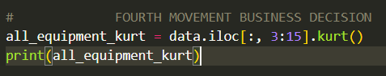

**OUTPUT:**

